**Replacement of VME Electronics for the Beamline Control System at GSECARS, APS Sector 13**

**Mark Rivers**

**August 23, 2024**

Overview 2

Serial Devices 3

Analog I/O, Digital I/O, Counter/Timer, Multi-Channel Scaler 4

USB-CTR08 4

USB-1808X 7

USB-3104 9

E-DIO24 10

Packaging of Measurement Computing devices 11

Motion Control 14

Overview 14

Stepper Motors with Step-Pak and Phytron Drivers 15

Stepper Motors with On-Board Drivers 19

Servo Motors with On-Board Drivers 20

Allen-Bradley SLC-5/03 PLC Interface 21

Network Architecture 21

Linux Control Computers 21

Acknowledgements 22

## Overview

As with most APS beamlines, GSECARS has been using VME crates for beamline controls since the beginning. These VME crates have been controlling the following:

|  |  |
| --- | --- |
| **Devices controlled** | **VME hardware used at GSECARS** |
| Serial devices, e.g. vacuum pumps and controllers, Stanford current amplifiers, Keithley electrometers, etc. | IP-Octal |
| Analog input | IP-330 |
| Analog output | IP-DAC128V |
| Digital I/O | IP-Unidig |
| Counter/ timer, multi-channel scaler (MCS) | Joerger VSC, SIS3800, SIS-3820 |
| Motors | OMS58 and MAXv |
| Allen-Bradley PLC for EPS | A/B 6008SV (blue hose) |

The VME systems have generally been very reliable, and there is a significant dollar investment in them. However, VME has several significant disadvantages:

* Poor price/performance
* Difficult development environment
* vxWorks is expensive
* Aging technology: existing devices are obsolete, few new devices are available
* Local vxWorks expertise is disappearing

GSECARS has 9 hutches at sector 13: Two first-optics enclosures (13-BM-A, 13-ID-A), two second-optics enclosures (13-BM-B, 13-ID-B), and five experimental stations (13-BM-C, 13-BM-D, 13-ID-C, 13-ID-D, 13-ID-E). There were seven VME crates at the beamlines: one for each FOE, and one for each experimental station.

The VME crates had a total of 50 8-channel motor controller cards, 43 OMS58 and 7 MAXv. These could drive a total of 400 motors. All motors controlled from the VME crates were open-loop stepper motors with no encoders. Most of the drivers were Step-Paks, but about 20 were 8-channel BP-8000 driver boxes built at the University of Chicago. These were low-current half-step driver boxes used to drive small motors like Newport MFN and MFA stages. The Step-Paks were all located in racks on the enclosure roofs, while the BP-8000s were typically placed in the experimental stations.

In addition to the VME motor controllers, GSECARS has 17 Newport XPS 8-channel motor controller/drivers, 2 Aerotech controller/drivers, and about 10 ACS MCB-4B controller/drivers. The XPS and Aerotech drivers are typically used for higher performance DC-servo systems in the experimental stations (e.g. goniometers, hexapods, air-bearing rotation stages), while the VME/Step-Pak systems are used for simpler motion components.

GSECARS decided to replace all the VME systems with modern electronics during the APS dark year. Because we had not been given major new funding to accomplish this, the conversion needed to be cost-effective. We also tried to minimize the impact on the higher-level control system, for example preserving EPICS PVs names wherever possible. We chose Linux as the operating system to run all the VME-replacement hardware.

We purchased a Dell server running Linux for each experimental station. This server is placed in the same rack that the VME crate formerly occupied. We placed a new Moxa terminal server, a 24-port network switch, and a box containing 3 Measurement Computing devices in the same rack. This was convenient because the serial, analog, digital, and counter/timer/MCS signals already came to this rack. These devices are described in more detail below.

The VME replacement at GSECARS is complete, and all the VME crates have been decommissioned.

## Serial Devices

Replacing VME serial I/O is very straightforward. We chose Moxa NPort6650-16 terminal servers. These are 16-channel terminal servers with RJ-45 connectors. We are configuring them (baud rate, parity, etc.) with the built-in Web interface. We could have also chosen to configure them in the EPICS startup script using the RFC-2217 interface supported by asyn.

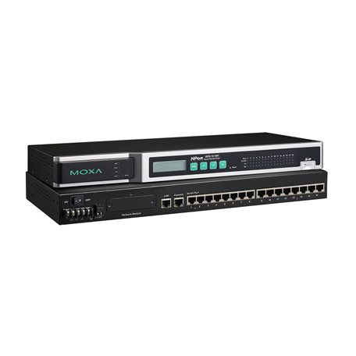

**Photo 1: Moxa NPort6650-16 terminal server, front and read panel views.**

## Analog I/O, Digital I/O, Counter/Timer, Multi-Channel Scaler

We have chosen to use 3 USB devices from Measurement Computing for these functions. An alternative we considered was LabJack, who do make Ethernet devices with analog and digital I/O. However, they do not have any device comparable to the Measurement Computing USB-CTR08 that can replace the Joerger scaler or SIS 3820 scaler/MCS. While we might have preferred to use Ethernet devices, given that the USB-CTR08 is USB, we chose other Measurement Computing USB devices as well, particularly since these have higher-performance than their similar Ethernet devices. The following highlights the capabilities of each of these Measurement Computing devices.

### USB-CTR08

This device costs $489 and is mainly used to replace the Joerger scaler and/or SIS3800 or SIS3820.

* 8 counter inputs
  + 48 MHz
  + 64-bit counter depth
* 4 timing generator outputs
  + 48 MHz
  + Programmable frequency, duty cycle, polarity, number of pulses
* 8 digital I/O
  + Individually programmable direction
* Support for EPICS scaler record
* Support for Multi-Channel Scaler (similar to SIS 3820)
  + Minimum dwell time 250 ns per active counter
  + Internal or external channel advance
  + Divide by N on external channel advance
  + Can also capture values of 8 digital input bits in each dwell period

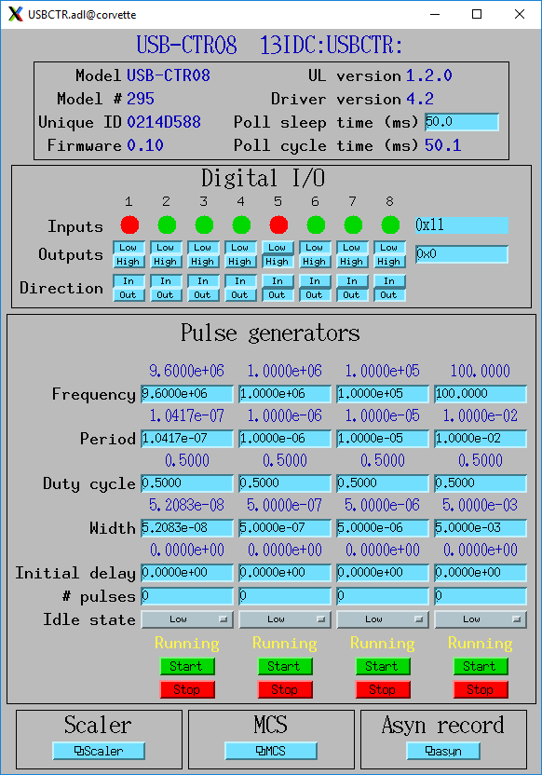

**Top-level screen for the USB-CTR08**

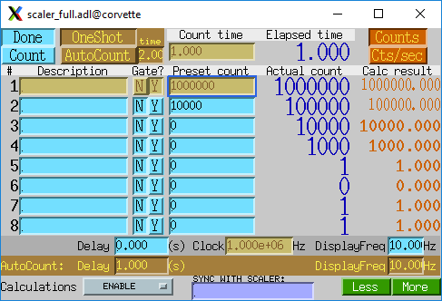

**EPICS scaler record screen for the USB-CTR08**

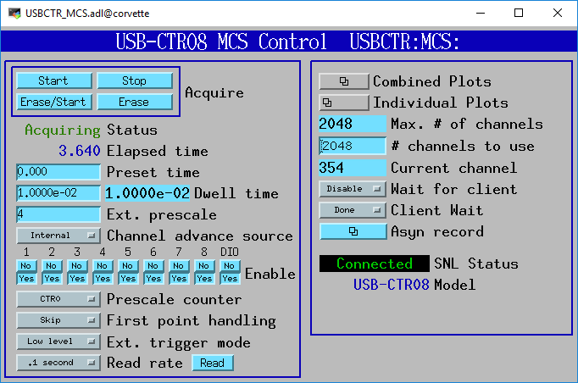

**Multi-channel scaler (MCS) screen for the USB-CTR08**

### USB-1808X

This device costs $989 and is mainly used to replace the IP330 or other analog input device.

* 8 analog inputs
  + 18-bit, simultaneous sampling
  + ±10V, ±5V, 0-10V, 0-5V ranges
  + Single-ended or differential
  + Streaming input (waveform digitizer)
    - Up to 200 kHz
    - Any combination of analog, encoder, counter, digital inputs
* 2 analog outputs
  + 16-bit
  + +- 10V range
  + Streaming output (waveform generator)
    - Up to 500 kHz
    - Any combination of analog and digital outputs
* 2 differential encoder inputs
  + 50 MHz
* 2 timing generator outputs
  + 50 MHz
  + Programmable frequency, duty cycle, polarity, number of pulses
* 2 counter inputs
  + 50 MHz
* 4 digital I/O
  + Individually programmable direction

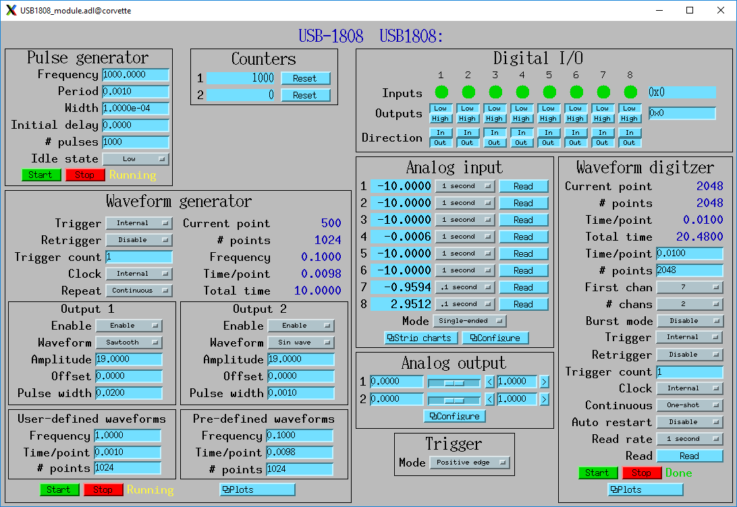

**Top-level screen for the USB-1808X**

### USB-3104

This device costs $519 and is mainly used to replace the IP-DAC128V or other analog output device.

* 8 analog outputs
  + 16-bit
  + ±10V, 0-10V ranges
  + Synchronous update input
* 1 counter input
  + 1 MHz
* 8 digital I/O
  + Individually programmable direction

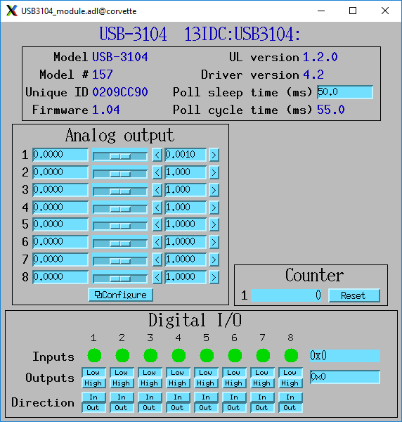

**Top-level screen for the USB-3104**

### E-DIO24

This device costs $335 and is mainly used to provide additional digital I/O when needed.

* 24 digital I/O
  + Individually programmable direction
* 1 counter input
  + 10 MHz

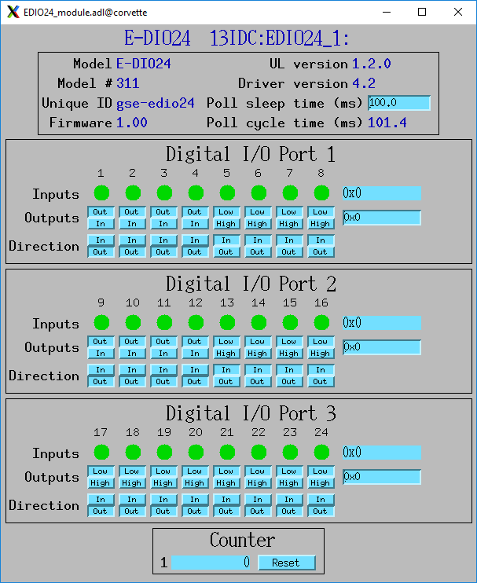

**Top-level screen for the E-DIO24**

### Packaging of Measurement Computing devices

GSECARS has packaged the USB-CTR08, USB-1808X, and USB-3104 into a 3U 19” rack mount box. It contains a StarTech ST4200USBM USB 2.0 hub so there is only a single USB cable connection on the rear of the box. The Measurement Computing devices are USB 2.0. The maximum USB data rate can be calculated as follows:

* USB-1808X input: 200k samples/s, 3 bytes/sample = 0.6MB/s
* USB-1808X output: 500k samples/s, 2 channels, 2 bytes/sample = 4 MB/s.
* USB-CTR08 input: 4M samples/s, 2 bytes/sample = 8 MB/s.
* Total: 12.6 MB/s

The maximum USB data rate to/from the box is thus 12.6 MB/s. USB 2.0 is capable of at least 30 MB/s, so the devices use less than 40% of this. We have tested that all 3 devices can stream data at their maximum rates over the single USB cable to the Linux host with no errors. The internal wiring for all high-speed inputs and outputs uses coaxial cable to minimize crosstalk and noise.

We mount this box in the same rack as the Linux server for the experimental station it serves. This means the USB cable is less than 2 meters. However, using active USB extenders, such as this 20 m one from SIIG (<https://www.siig.com/products/it-products/usb-a-usb-c/extenders/usb-3-0-active-repeater-cable-20m.html>) the distance from the computer to the box can be over 20 m for installations where this is desired.

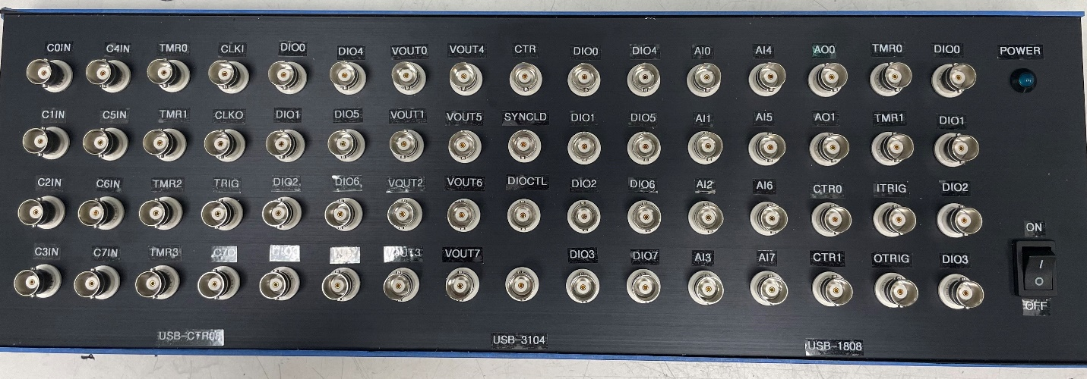

**Photo 2: Front panel of GSECARS box housing USB-CTR08, USB-1808X, and USB-3104**

GSECARS has packaged the E-DIO24 in a 2U 19” rack mount with the BCDA relay cards for pneumatic actuators as shown in Photo 3 below.

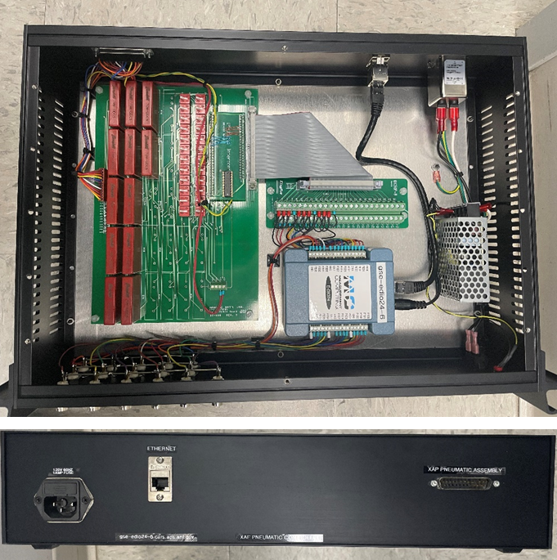

**Photo 3: E-DIO24 controlling BCDA relay card for pneumatic valves. Top and rear panel views.**

We have also packaged the E-DIO24 in a 2U 19” rack mount to control two XIA PFCU-4 filter controllers using with 2 DB-9 connectors (Photos 4 and 5 below). Each PFCU-4 has 4 inputs and 4 outputs, so the box uses 16 of the 24 I/O signals from the E-DIO24.

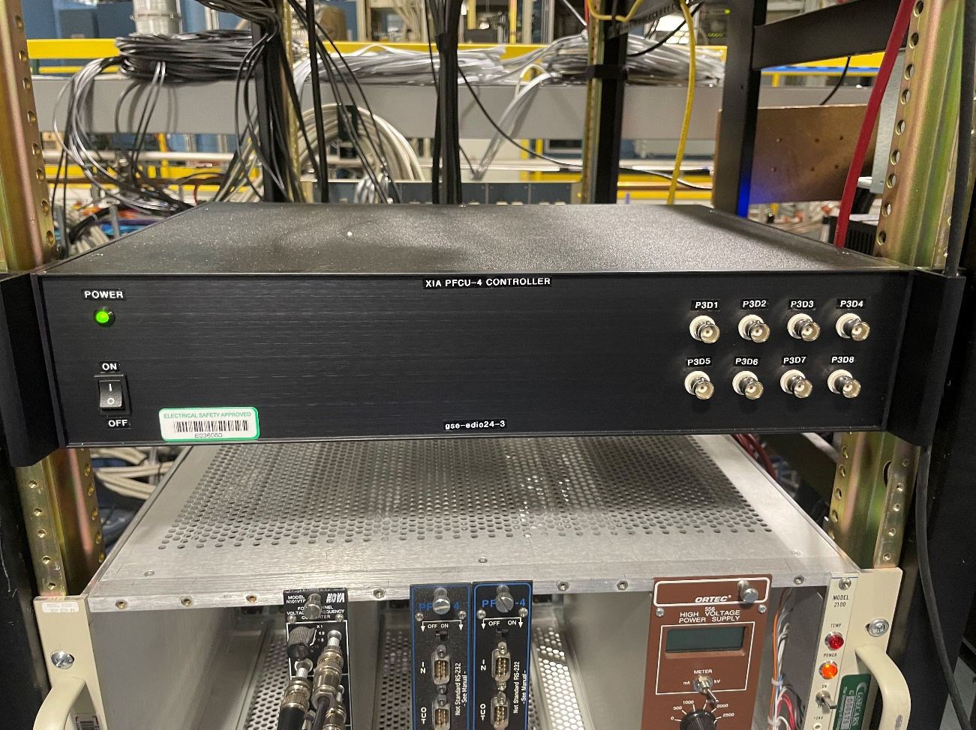

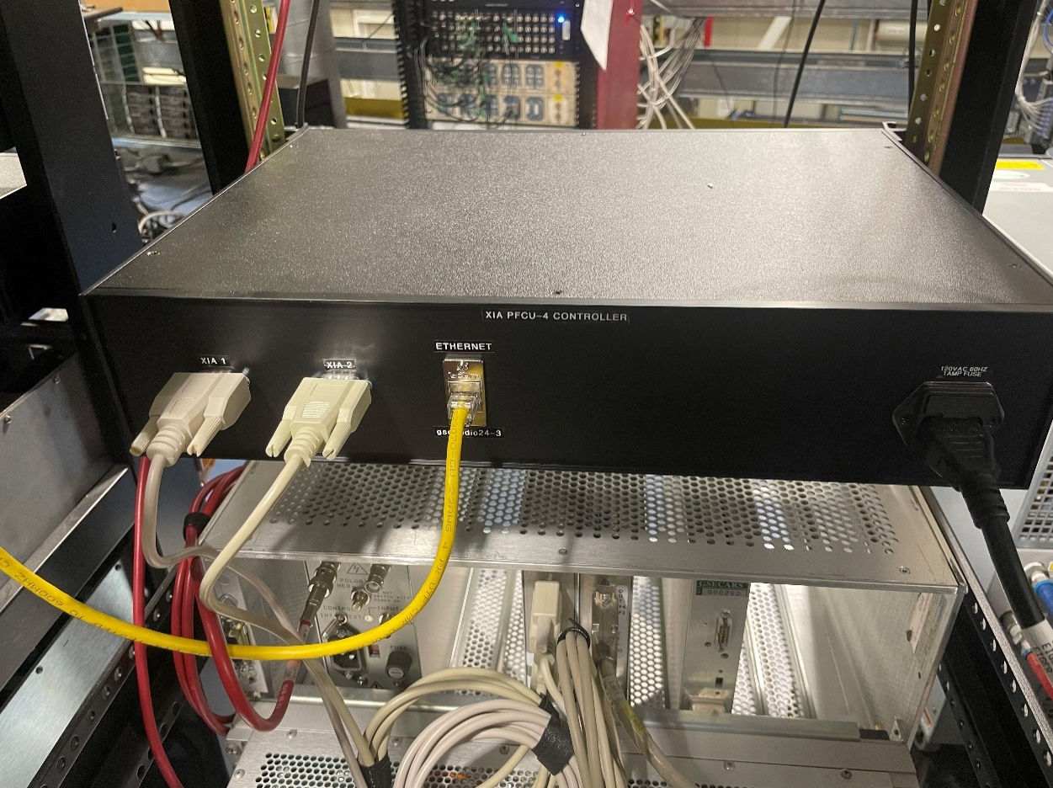

**Photos 4 and 5: E-DIO24 controlling 2 XIA PFCU-4 filter controllers. Front and rear panel views.**

For a single PFCU we have used 8 of the 20 digital I/O signals on the main Measurement Computing enclosure. 8 Lemo coaxial cables go from the enclosure BNC connectors to the DB-9 on the PFCU.

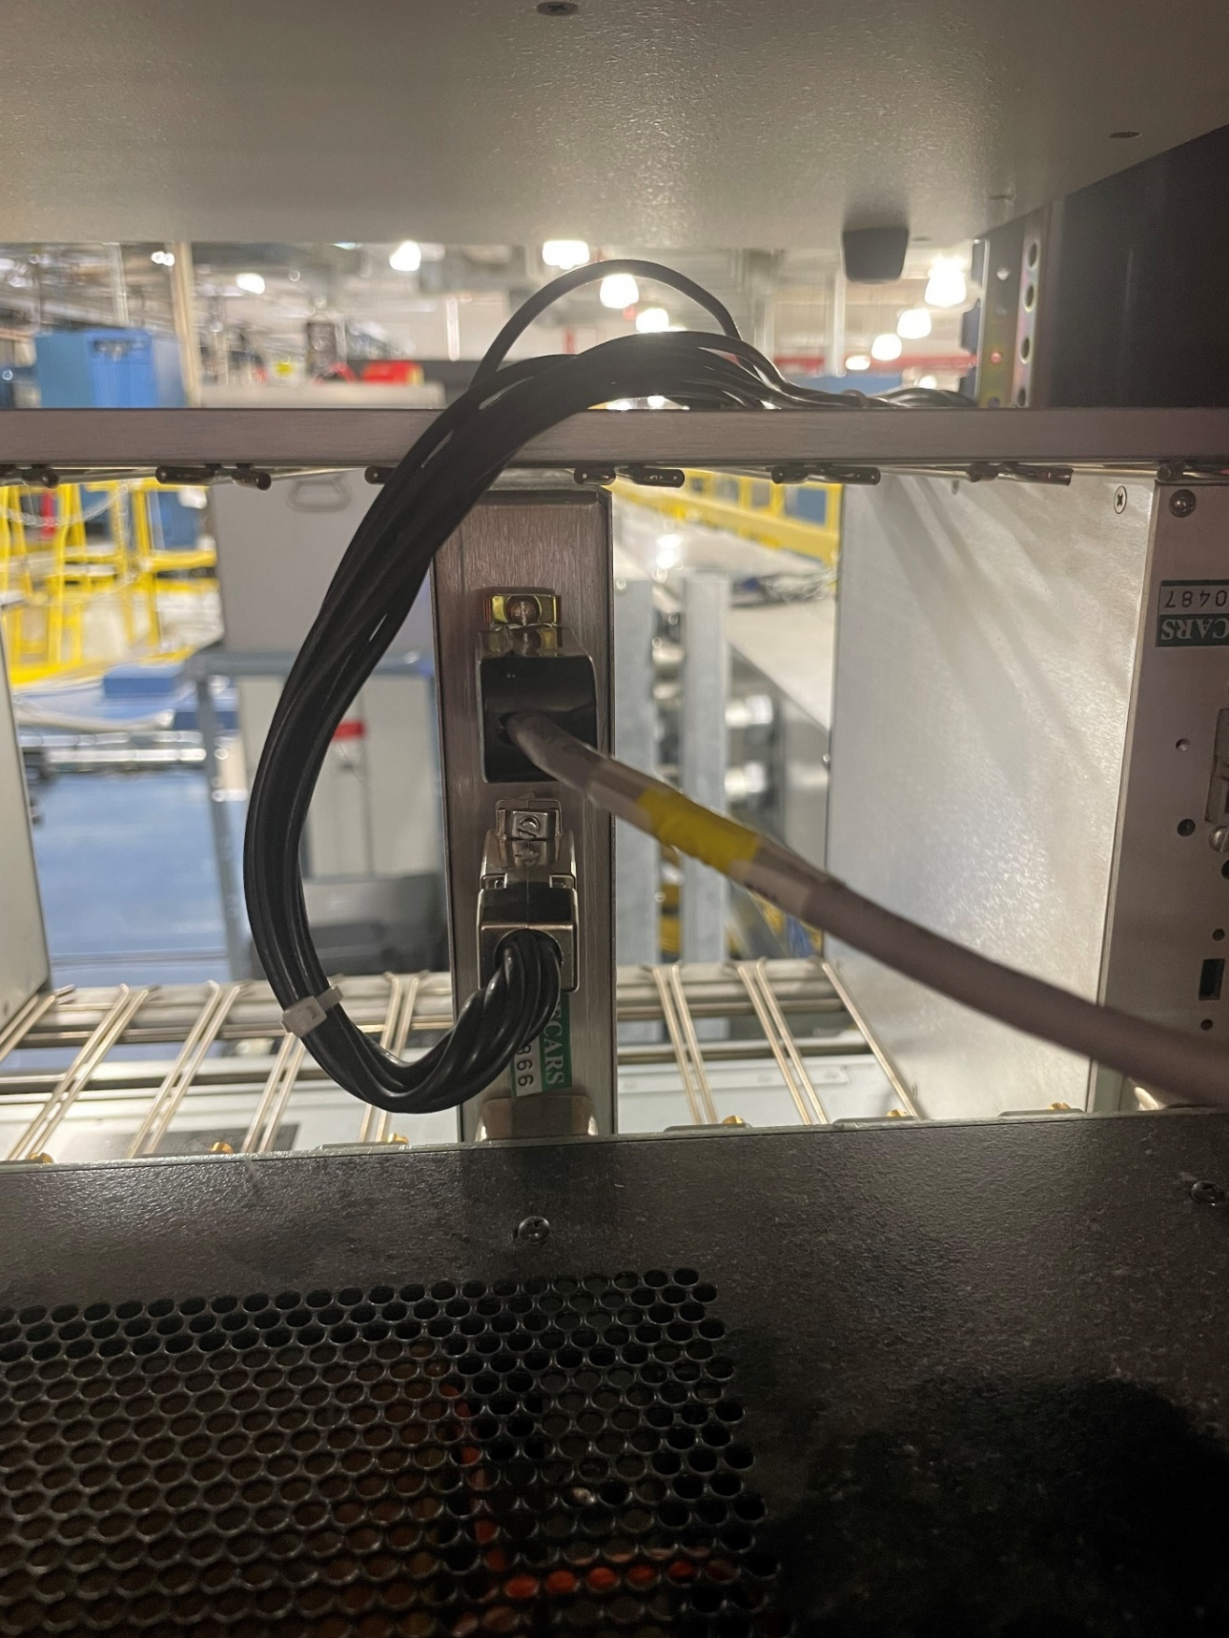

**Photo 6: Rear of XIA PFCU-4 with 8 Lemo cables from Measurement Computing enclosure (Photo 2) into DB-9.**

## Motion Control

### Overview

Replacing the OMS motion controllers is by far the most complex and expensive component of replacing the VME systems. The ACS Motion controllers that the APS is purchasing for APS-U, and the Newport XPS controllers we have been using at GSECARS both cost in excess of $16K for an 8-axis system, or more than $2,000 per axis. Since GSECARS is replacing 400 axes of control this would cost more than $800,000, which is far beyond our available budget. We researched alternatives and selected the Galil DMC-4183 controller. This controller has many of the advanced features of the ACS Motion and Newport XPS controllers, including:

* Complex coordinated multi-axis motion
* On-board motion programs
* Position compare output for triggering detectors
* Support for incremental and absolute encoders
* Optional on-board drivers for a variety of stepper and servo motors

There is a mature EPICS driver written at the Australian Synchrotron, and these controllers are in use at a number of large EPICS sites, including the Australian Synchrotron and the SNS at Oak Ridge.

The standard DMC-4183 configuration has step and direction outputs, and so it can be used with our existing Step-Pak and Phytron drivers. Our cost for this version (DMC-4183-BOX8) is about $2,100, or $265 per axis. On-board stepper, servo, and 3-phase brushless amplifiers are also available, and most amplifier modules drive 4 axes. The following are the amplifier/driver options we are currently using at GSECARS. These on-board drivers have programmable drive current, holding current, and micro-stepping, all controlled through EPICS. Note that many more driver options are available beyond those we are currently using, including models that can drive both steppers and servos.

|  |  |  |
| --- | --- | --- |
| **Model** | **Description** | **List Price** |
| D4040 | 1.4 amp micro-stepping drivers, 4 axes | $205 |
| D4140 | 3.0 amp micro-stepping drivers, 4 axes | $675 |
| D3140 | DC servo drives (brush only), 20 W, 4 axes | $205 |
| D3040 | DC servo drives, 500W, 4 axes | $790 |

The following table lists the versions of the DMC-4183-BOX8 that we have purchased at GSECARS. These all drive 8 axes.

|  |  |  |  |
| --- | --- | --- | --- |
| **Model** | **Description** | **Application** | **Our Price** |
| -D4040-D4040 | 1.4 A micro-stepper | Replace BP-8000 for small stepper motors. Typically placed in the experimental station. | $2,430 |
| -D4140-D4140 | 3.0 A micro-stepper | Most are currently used with Step-Paks and Phytron drivers. In the future we may eliminate Step-Paks and use them to directly drive motors | $3,190 |
| (ISCNTL)-D3140-D4040(ISAMP) | 20W servo (4 axes) and 1.4A micro-stepper (4 axes) | Replace Newport XPS to drive a mix of small stepper and servo motors. | $2,430 |
| ABCD(SER)-EFGH(SER) | 8 axes, no drivers, absolute encoders | Used with Phytron drivers, BISS absolute encoders inputs. | $2,403 |

Note that the cost for 8-axis controllers with on-board drivers is less than 20% of the cost of an ACS Motion or Newport XPS controller. This cost does not include the power-supply and packaging that needs to be done with the Galils, but even including that the cost is much less.

At GSECARS we have packaged the Galils into 2U 19” rack mount boxes. The following sections describe the boxes we built for the various versions described above.

### Stepper Motors with Step-Pak and Phytron Drivers

The DMC-4183 has a high-density female DB-26 connector for each axis. This connector has all the digital controls for the axis, including step and direction, limit inputs, encoder inputs, etc. These are the connectors labeled AXIS A-AXIS H in Photo 7 below.

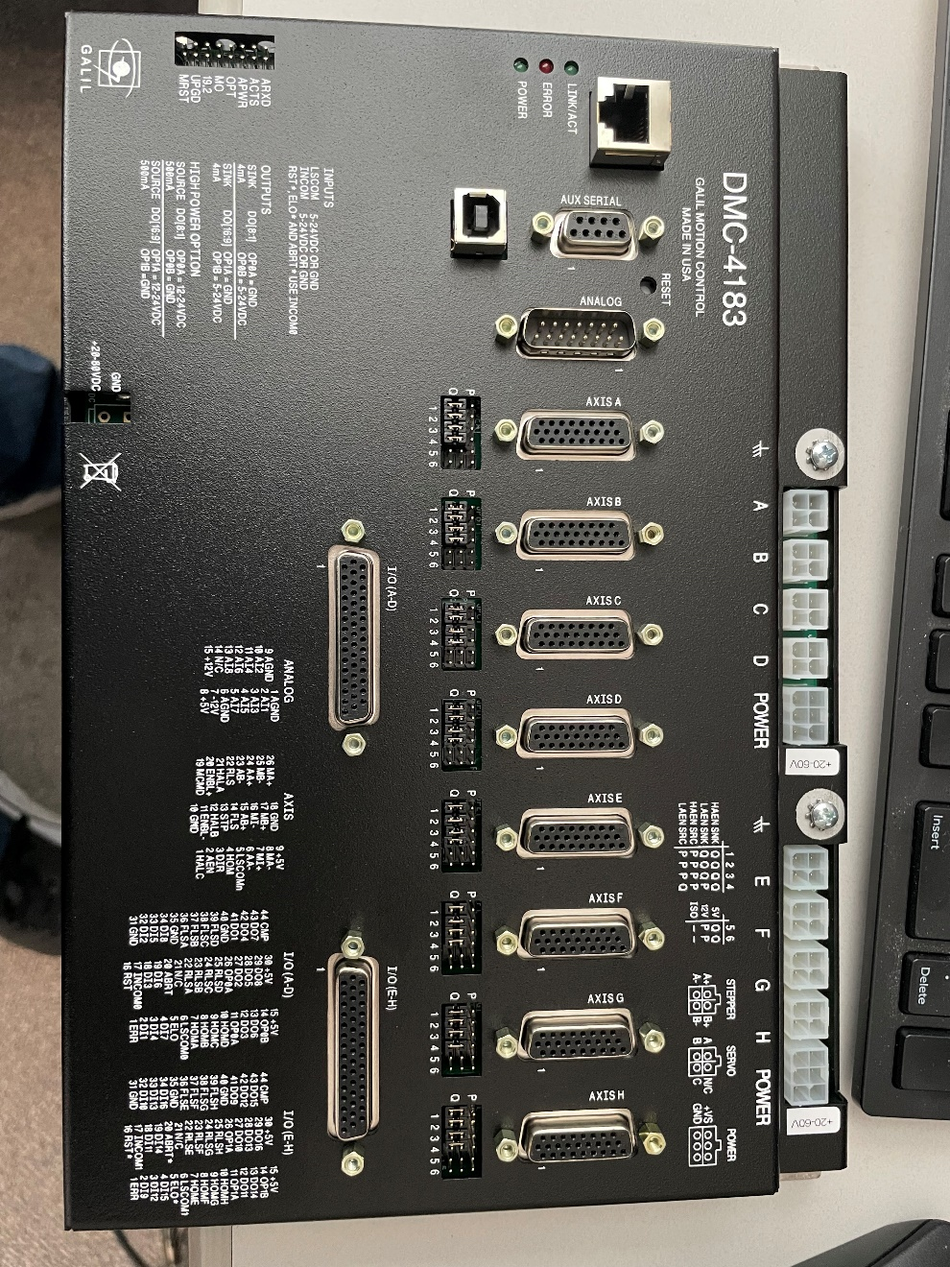

**Photo 7: DMC-4183-BOX8-D4140-D4140**

To use this with the Step-Pak the step, direction, and limit signals need to be on an RJ-45 cable (for the Step-Pak SPC-4 interface module) or on a DB-25 cable (for the Step-Pak SPC-3 interface module). The step and direction outputs from the DMC-4183 are single-ended, while the Step-Pak requires differential inputs. At GSECARS we don’t use encoders with any of the Step-Paks, and so we prefer to use RJ-45 cables. Our solution to convert from DB-26 to RJ-45 and to convert from single-ended to differential was to design and build a small circuit board for each Galil channel. The circuit board has a DB-26 male connector on one edge, and an RJ-45 female connector on another edge (Photo 8 below). It also has a 2-pin connector which contains the step signal, which is brought to a BNC connector on the enclosure. This signal can be used for on-the-fly scanning. For example, the Measurement Computing USB-CTR08 can divide this step out signal by N and use it for the MCS channel advance and triggering other detectors. This circuit board costs about $1 each to manufacture in quantity (unstuffed).

GSECARS has packaged most of the Galil controllers that are using Step-Pak drivers into 2U enclosures, each housing 2 controllers (16 channels). Photo 8 below shows the small circuit boards installed in each of the 16 channels.

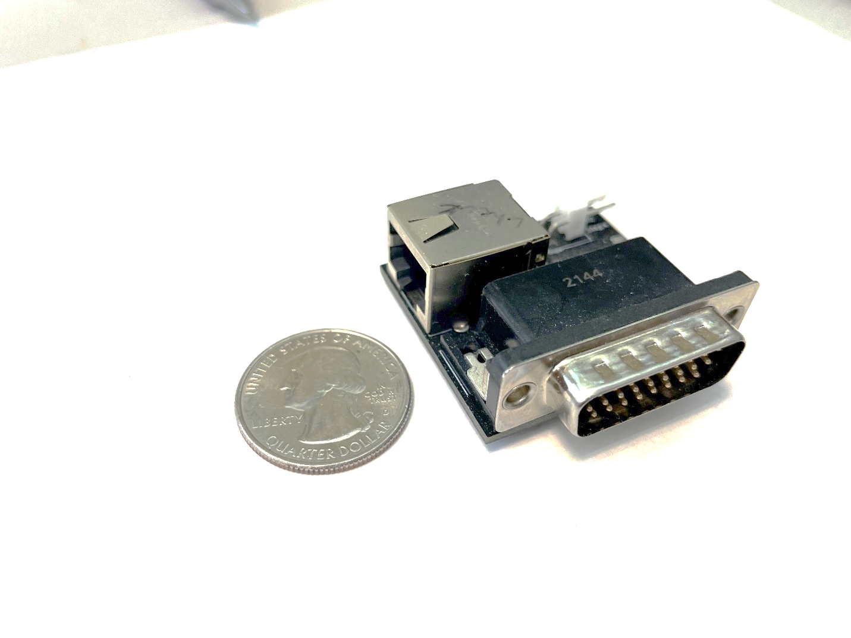

**Photo 8: GSECARS designed circuit board that brings step, direction, and limits via RJ-45 cable to the front-panel connectors.**

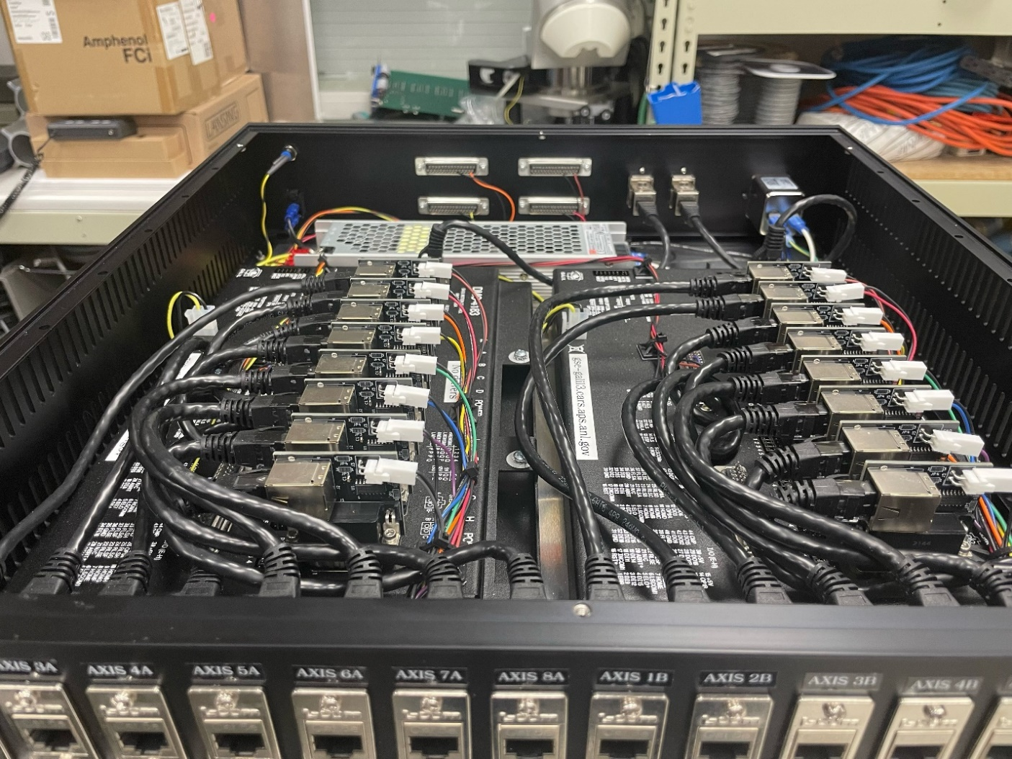

**Photo 9: GSECARS 2U enclosure containing 2 DMC-4183 controllers. Each controller has 8 circuit boards installed in the DB-26 connectors.**

Photo 10 below shows the front panel of this enclosure. There are 16 RJ-45 connectors for connections to the Step-Pak or Phytron drivers. The BNC connectors are the step out signals that can be used for on-the-fly scan triggering. The rear panel of this enclosure has 2 RJ-45 network connections, the AC power input, and the power switch.

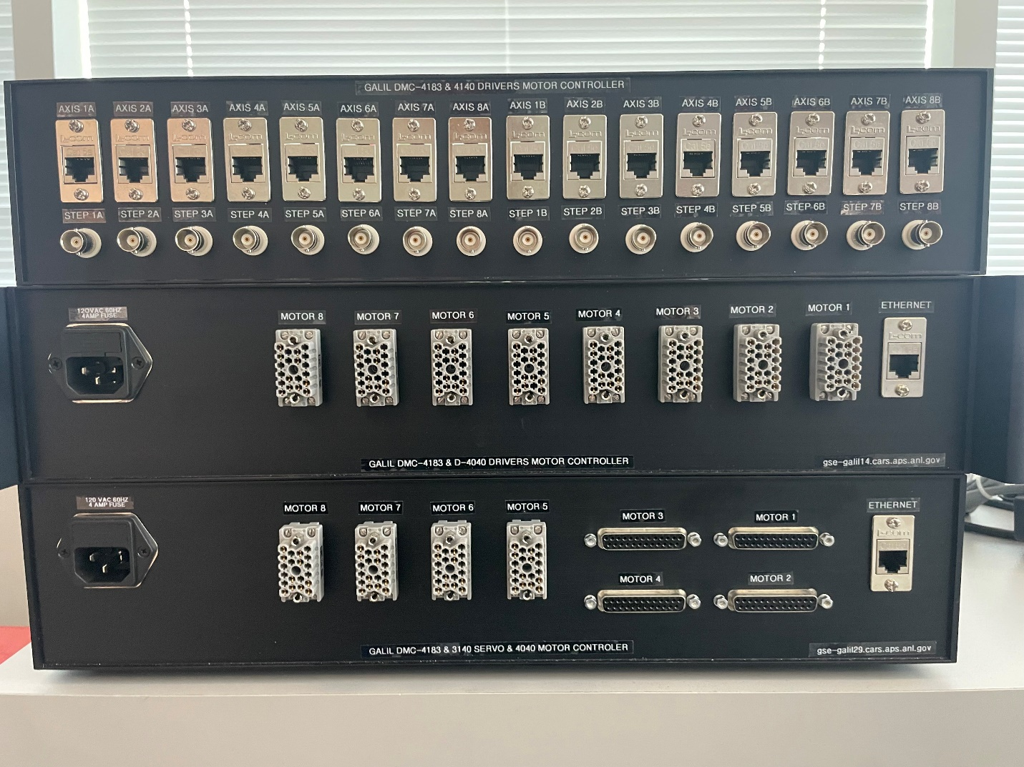

**Photo 10: Front panel of GSECARS 2U enclosure with 16 RJ-45 connectors**

Photo 11 below shows one of these dual enclosures which is controlling two Step-Paks. The connection to the Step-Paks is via thin CAT6A RJ-45 cables. The upper Step-Pak has the SPC-3 interface which takes RJ-45 cables directly. The bottom Step-Pak has the SPC-4 interface with DB-25 connectors. We have installed RJ-45 to DB-25 converters with the appropriate wiring to use this older model. This photo illustrates that by placing the Galil controllers in the same rack at the Step-Pak all the cabling is local to the rack, compared to large cable bundles that typically ran between the VME crate and the Step-Pak.

We have installed 16 of these dual-controller enclosures with RJ-45 connectors to be used with Step-Pak or Phytron drivers.

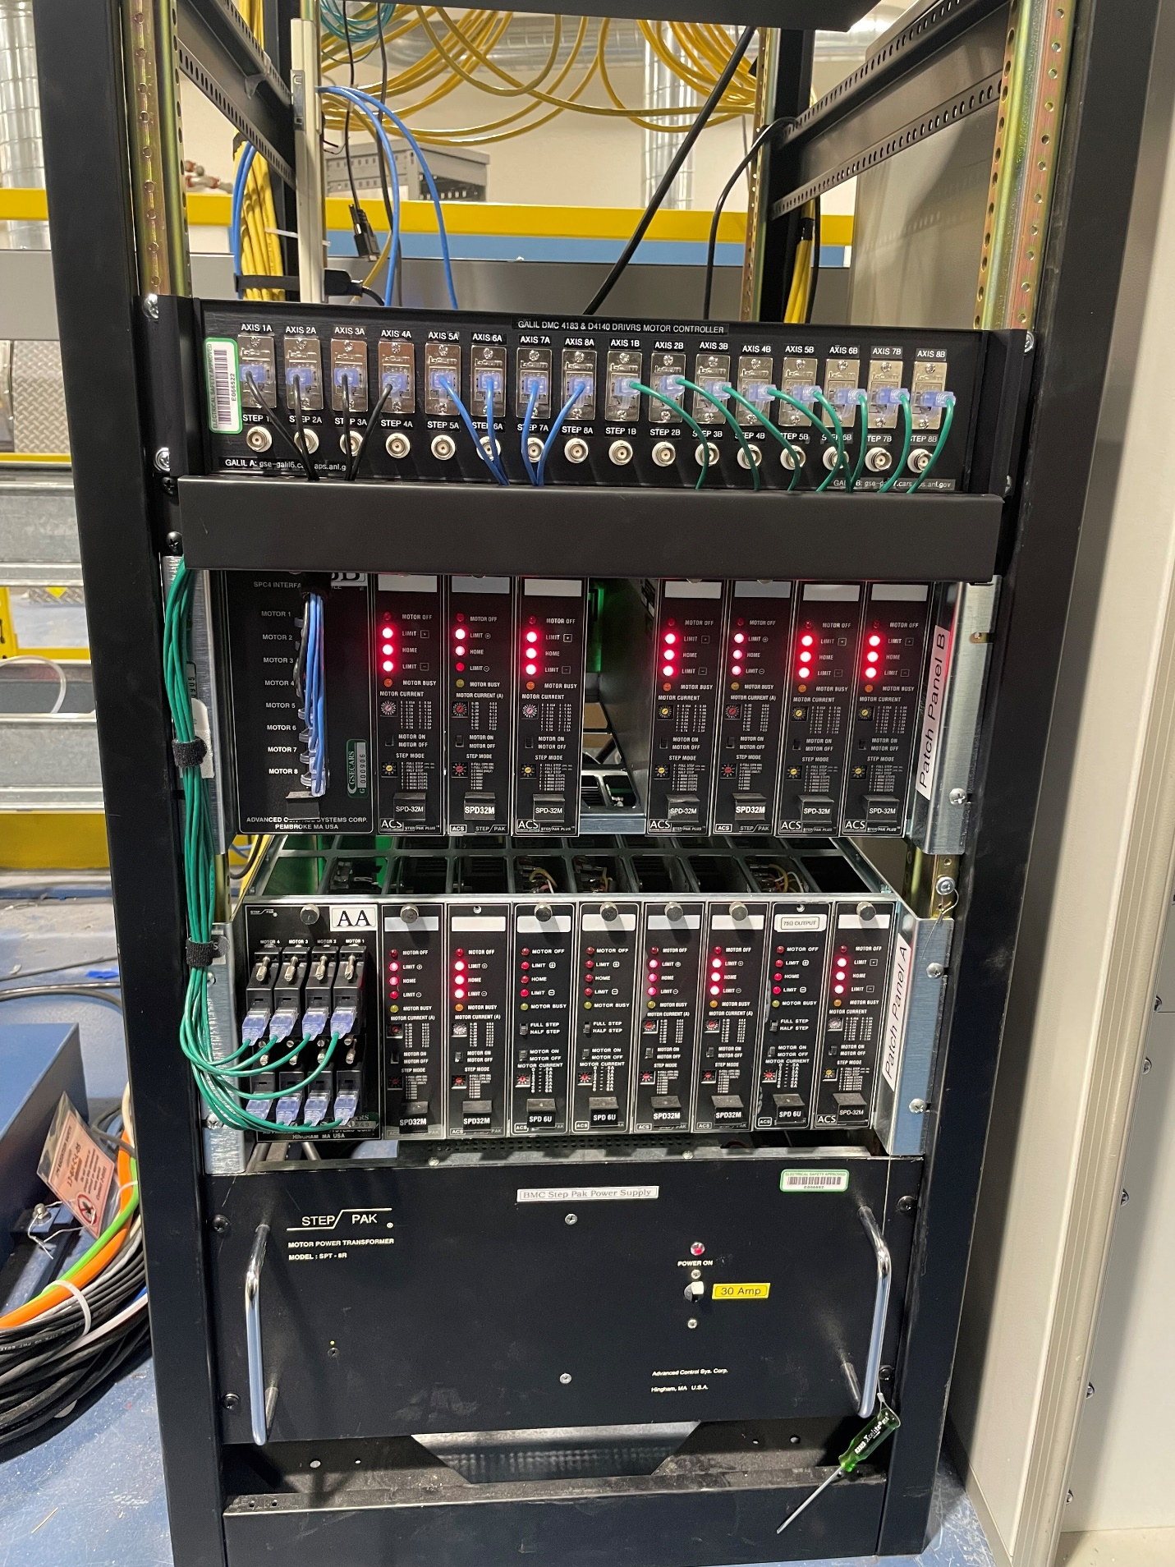

**Photo 11: Rack at 13-BM-B containing GSECARS 2U enclosure with 2 Galil controllers, and 2 Step-Paks**

All the controllers we are using the drive the Step-Paks were purchased with the on-board D4140 3A micro-stepping drivers. However, we have currently only replaced the Step-Paks with these on-board drivers in the 13-ID-E station, which previously used 3 Step-Paks. We are using this station to test the reliability of the Galil on-board drivers. With the Step-Paks it is easy to replace a faulty driver card. That is not true with the Galils, where the on-board cards each run 4 motors, and these are not easily replaced. If we are satisfied with the reliability of the on-board drivers, then we may eventually replace all the Step-Paks at GSECARS. It should be noted that the cost of Galil with 8 on-board drivers is significantly less than the cost of a single Step-Pak with 8 driver cards, so we can afford to have some spare Galils in case of failures.

### Stepper Motors with On-Board Drivers

Some of the controllers with the on-board D4040 or D4140 drivers are packaged into a 2U enclosure like that in Photo 12 below. This enclosure holds a single controller and has 8 ELCO connectors which do directly to the stepper motors.



**Photo 12: GSECARS 2U enclosure with one Galil controller with on-board D4040 micro-stepping drivers. The ELCO connectors use the standard APS pinout for the stepper motors.**

Photo 13 below shows 3 enclosures with on-board D4040 drivers for the 13-ID-E station. These have replaced 3 Step-Paks in the bottom of the rack, one of which is partly shown in the photo. The ELCO cables that previously went to the Step-Paks were simply reconnected to these Galil enclosures in the same rack.

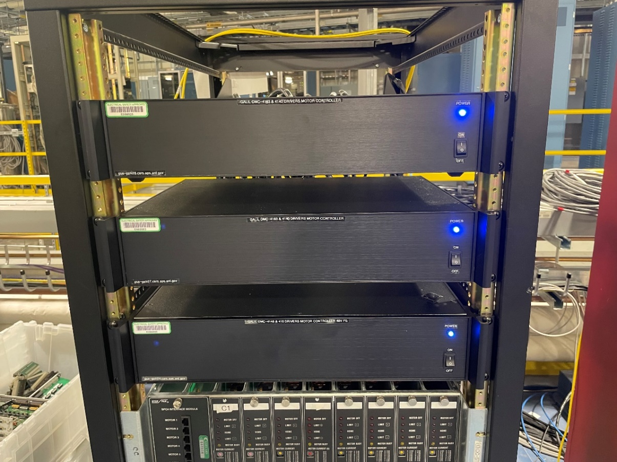

**Photo 13: Rack at 13-ID-E containing 3 enclosures with on-board D4040 micro-stepping drivers. There are 3 Step-Paks at the bottom of the rack that are no longer used**

We have installed a total of 15 enclosures with D4040, D4140, or D3140 drivers and Elco connectors to directly drive stepper and/or servo motors.

### Servo Motors with On-Board Drivers

Photo 14 below shows a box that drivers 4 small servo motors and 4 stepper motors. The servos use the on-board D3140 driver, and the steppers using the on-board D4040 driver. The servo motors have DB-25 connectors using the standard Newport XPS pinout. The ELCO connectors are for the stepper motors. We have tested the servo drivers with a variety of Newport stages, including the VP-25XA, MFA-CC, and UTS100CC. For this system we ordered the ISCNTL option. This means that the power supply for the controller is isolated from the power supply for the driver modules. We also ordered the ISAMP option, which means the D3140 and D4040 power supplies are also isolated. These were recommended so that the +-24V supplies for the servo drives were balanced, and not affected by changes in load to the stepper drives. We also installed the MO jumper on the DMC-4183. This ensures that the motors are powered off until explicitly turned on through EPICS. This prevents the servo motors from moving at all when the controller is powered on and off.

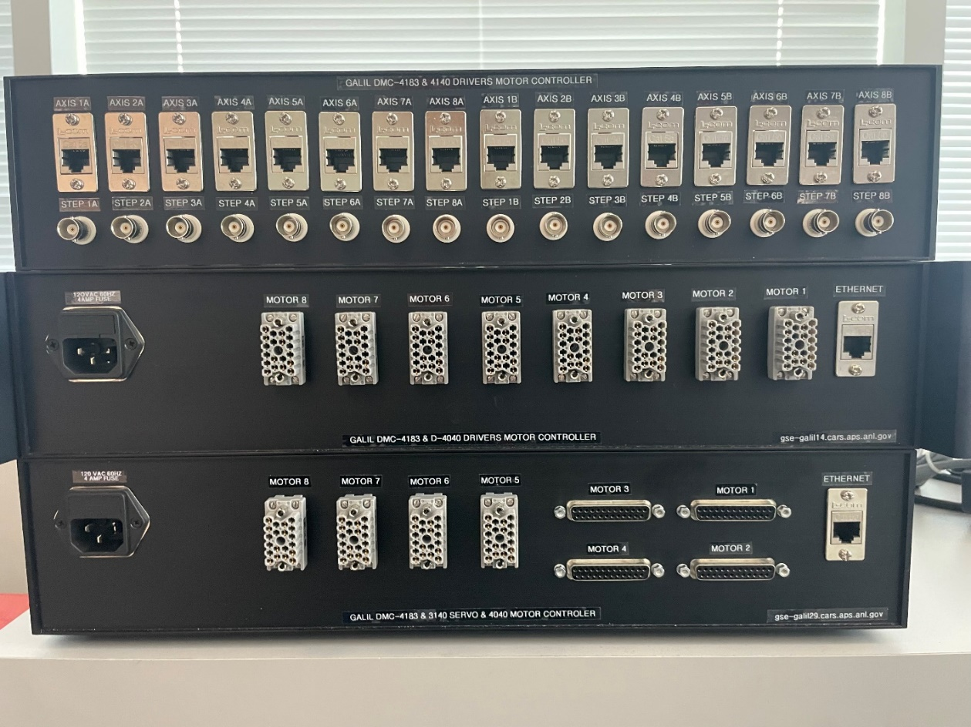

**Photo 14: GSECARS 2U enclosure with 1 Galil controller with D3140 servo drivers (channels 1-4) and D4040 micro-stepping drivers (channels 5-8).**

## Allen-Bradley SLC-5/03 PLC Interface

GSECARS is continuing to use the Allen-Bradley SLC 5/03 PLCs for our equipment protection system. These have proven very reliable, and we did not feel the estimated cost of $70K to have the APS replace these was justifiable. However, the EPICS communication with these PLCs was via the 6008SV VME card and the serial “blue hose” wiring, and we needed find a way to communicate with the PLCs without VME. We found that the ProSoft MVI46-MNET module can be used as a Modbus/TCP slave in the SLC 5/03 chassis over Ethernet. These are no longer manufactured, but we purchased 4 of these on eBay. We converted the ladder logic and EPICS IOC to use them. They are working well, and we have 2 spares.

## Network Architecture

The GSECARS network consists of both a public subnet (164.54.160.*) and a private subnet (10.54.160.*). These subnets share the same physical network, i.e. every port on every switch can be on either the public or private subnet, with no switch configuration required. Nearly all “devices” are on the private subnet, including motor controllers, terminal servers, data acquisition electronics, etc.

The tier 1 switch for the sector is in the APS network closet, and is managed by the APS. GSECARS has tier 2 switches with redundant 10 Gb/s fiber links to the tier 1 switch. We plan to upgrade these links to redundant 100 Gb/s fiber in the near future.

The rack for each station has a tier 3 HPE Aruba 1930 with 2 10Gb/s fiber ports and 24 1Gb/s ports. One 10 Gb/s fiber port is used for the uplink to the tier 2 switch.

## Linux Control Computers

As part of the VME replacement we added a new Linux server to each of the experimental station racks that formerly housed the VME crates. These are Dell PowerEdge R350 servers. These were about $1,900 each and are configured as follows:

* Intel Xeon E2334 3.4 GHz, 4 cores/8 threads, 16 GB RAM.
* 2 10Gb Ethernet fiber ports
* 2 on-board 1 Gb Ethernet ports
* 4 additional 1 Gb Ethernet ports
* Running RHEL 9.4.

These Linux machines run the IOCs for that experimental station. These are mounted in the same rack as the Measurement Computing USB devices described above, allowing the USB cable to be less than 2 meters. The rack also contains the tier 3 Ethernet switch described above (Photo 15 below). The computer has 2 10 Gb/s fiber connections to the switch, one on the public network, and one on the private network. The terminal server and most Measurement Computing Ethernet devices and Galils are also plugged into this switch. The private network connection means that most traffic to the devices is confined to this switch, reducing load on the rest of the network.

All the EPICS files (database files, executables, OPI screens, IOC directories, procServ log file, etc.) are kept on corvette, our central Linux server. The beamline Linux machines have very few local files and can be easily swapped in case of failures.

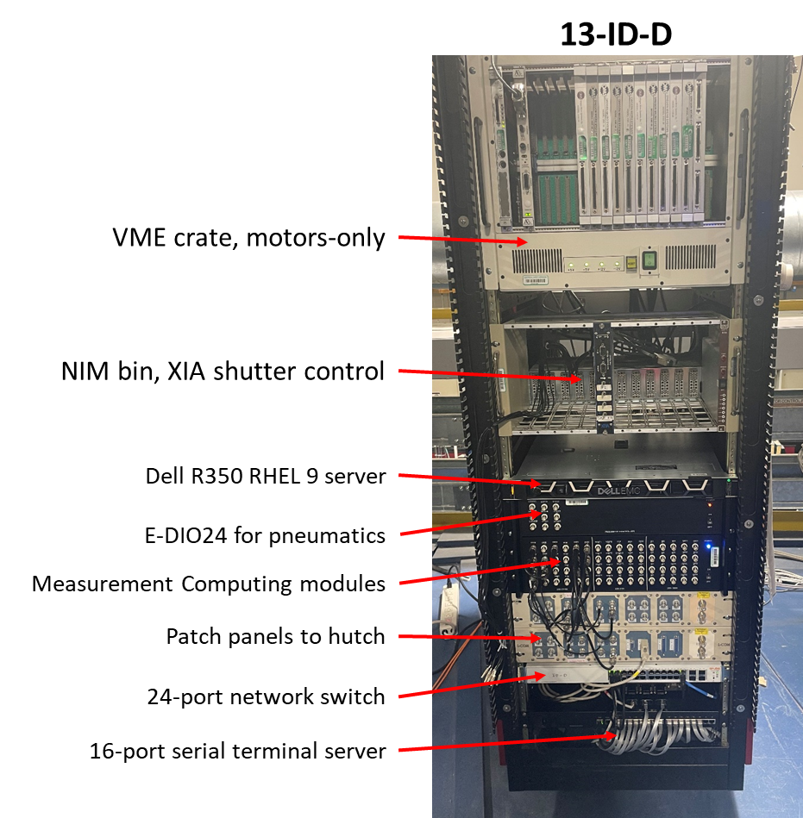

**Photo 15: Rack for 13-ID-D station, showing Linux server, Measurement Computing modules, HPE Aruba network switch, and Moxa terminal server.**

## Acknowledgements

Pasquale (Lino) Di Donna was instrumental to this project He designed and assembled 6 enclosures for the Measurement Computing devices and 33 enclosures for the Galil controllers. He also designed the Galil circuit boards and assembled about 300 of them.

Charlie Smith and Chris Skordas were responsible for the new Linux servers and the network infrastructure and cabling.